**Task 3**

**Name : Youssef Ahmed Hany**

Exercise 1&2:

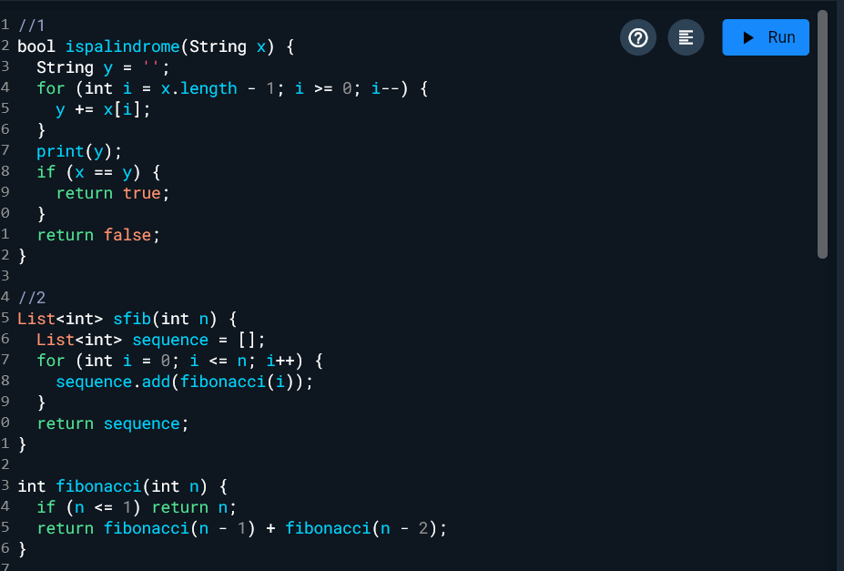

Exercise 3&4&5&6:

Exercise 7&8 :

Main:

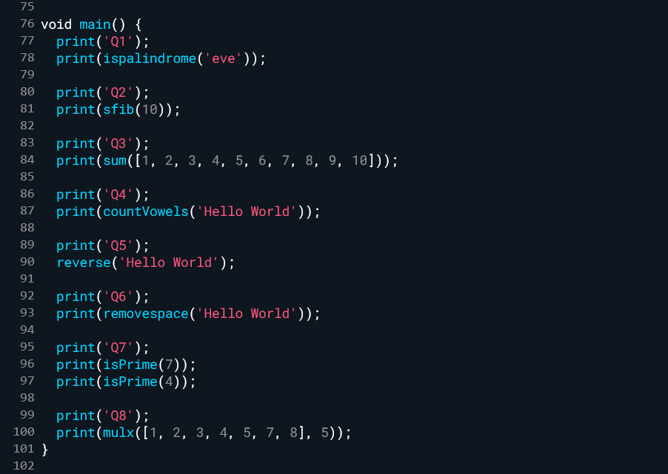

Output:

